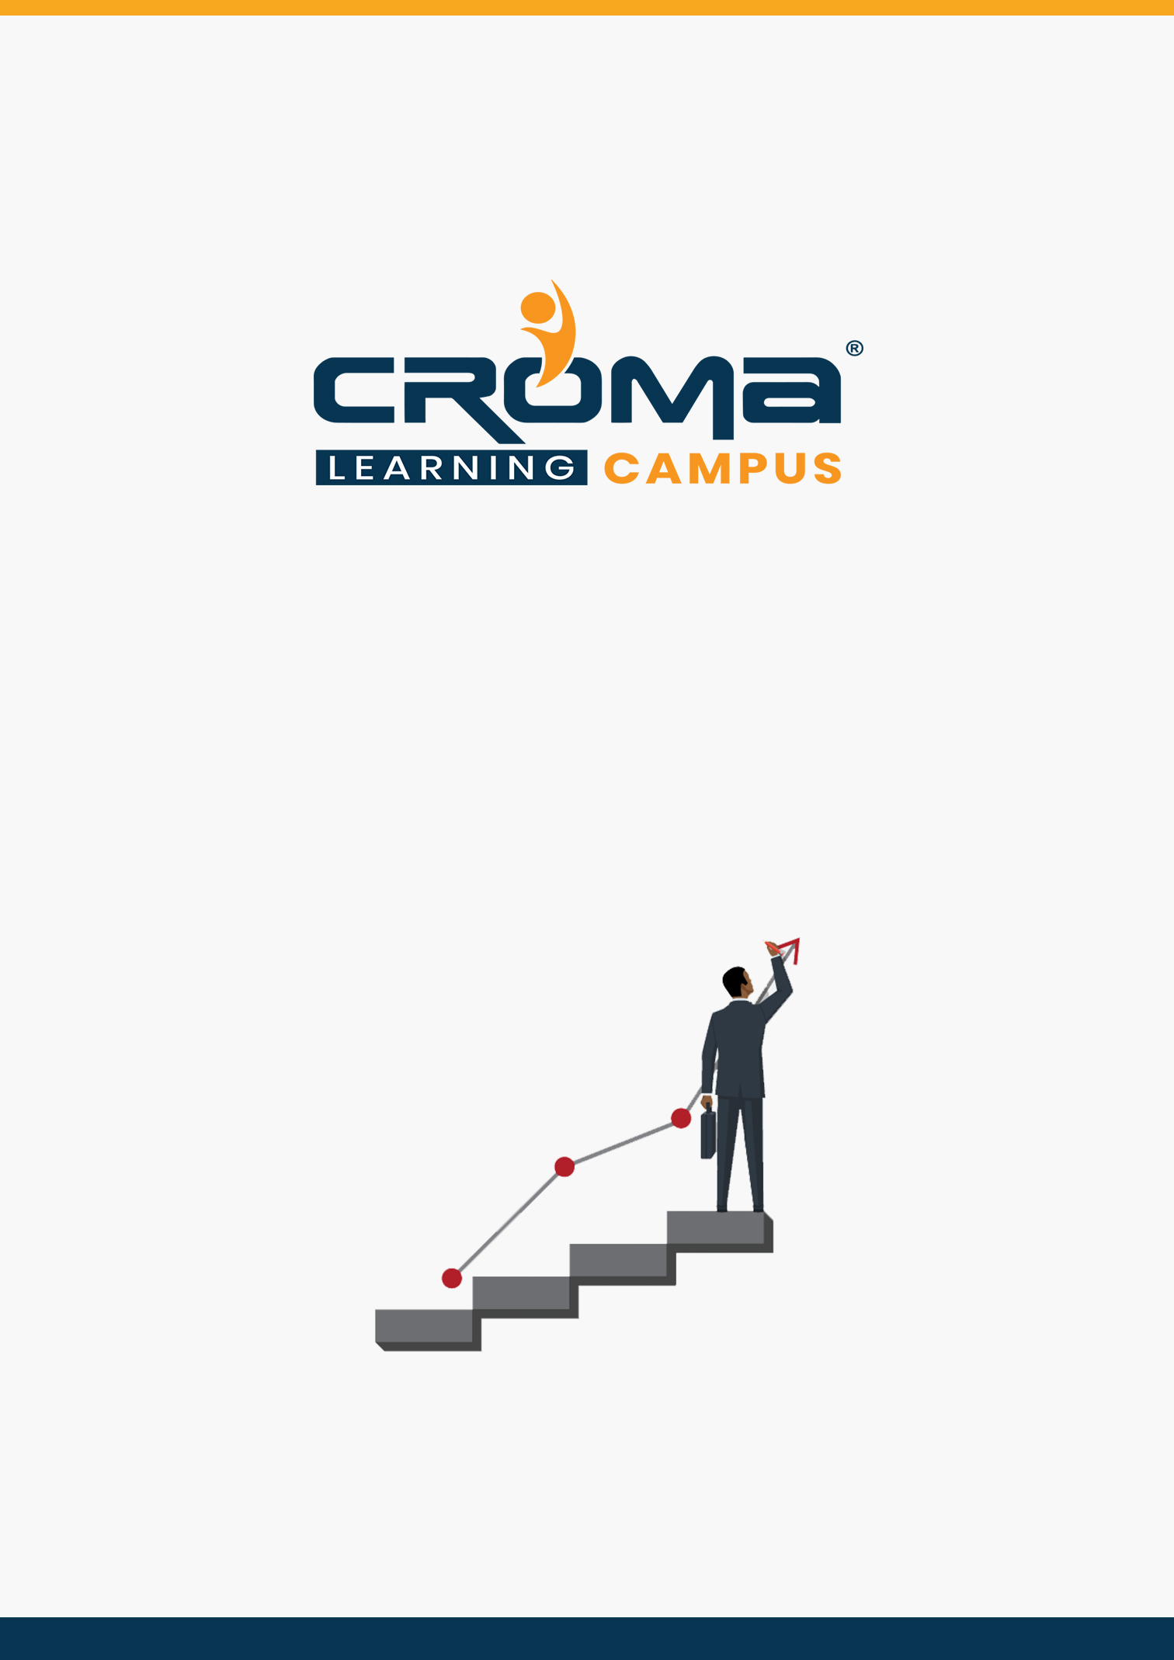

**Microsoft D365 Business Central Functional Training Curriculum**

**STRUCTURE**

**www.cromacampus.com | helpdesk@cromacampus.com | +91-120-4155255**

**Microsoft D365 Business Central Functional Training Curriculum**

*“Get in-depth knowledge of MD 365 business central functional Modules and make yourself stand out in the crowd.”*

**Course Objectives:**

* Learn all about Microsoft D365 Business Central Functional in-depth and get hands-on practical training too.
* Prepare yourself for the related global certification exam and get recognition
* Apply for leading MNCs and get hired by top industries across the world.
* Know all Microsoft Dynamics 365 Business Central fundamentals and functional concepts that are usually implemented within an organization.

**Course Description:**

Croma Campus offers the best Microsoft Dynamics 365 Business Central Functional Training in Noida with most experienced professionals. Our Instructors are working in Microsoft Dynamics 365 Business Central Functional and related technologies for years in MNC's.

We aware of industry needs and we are offering Microsoft Dynamics 365 Business Central Functional Training in Noida in more practical way. Our team of Microsoft Dynamics 365 Business Central Functional trainers offers the in-classroom training with best industry practices.

We framed our syllabus to match with the real-world requirements for both beginner level to advanced level. Our training will be handled in either weekday or weekends programme depends on participants requirements. Further, the course content is prepared keeping latest industry trends and certification structure in mind. To know more, you can contact our expert team and get more details.

**Course Content:**

**Module 1: Functional Roles & New Company Setup**

* What is an D365 Business central ERP
* Concept on an ERP
* Why Dynamics 365 business central is more successful?
* Modules of Functional in Business central.
* Role of Functional Person in Business Central
* Characteristics of Functional
* Difference between Nav and Business Central.
* Creation of New Company.
* Creation of Chart of Account.
* Accounting Period and accounting sub period.
* Complete setup after creating the blank company
* How to enter the opening of customer, vendor, Bank and Employee?

**Module 2: Sales**

* Basic concepts of sales Lead/Sales Quotation/Sales order
* Sales & Receivable Setup
* Creation of Sales Order and Effect of Sales Order after Posting
* Sales Shipment/ Sales Invoice/Sales Shipment and Invoice
* Sales Shipment Return/Sales Return/Sales Credit Memo
* Lab: Show Example on above mention related to sales.

**Module 3: Purchase**

* Basic concepts of Purchase / Purchase Order.
* Purchase & Payable Setup
* Creation of Purchase Order and Effect of Purchase Order after Posting
* Purchase Receipt/ Purchase Invoice/Purchase Receipt and Invoice
* Purchase Return/Sales Credit Memo
* Lab: Show Example on above mention related to Purchase.

**Module 4: Warehouse and Transfer Order**

* Warehouse employee setup
* Location setup for simple warehouse Lesson 3: warehouse receipt
* Warehouse ship
* Entry after posting warehouse receipt
* Entry after posting warehouse shipment
* Advance warehouse
* Advanced warehouse setup on location
* Creation of zone and bin
* Transfer bin item from one bin to another.
* Creation of entry on the zone then pick to bin
* How to use the bin contents?
* Warehouse entry
* Basic concepts of Inventory/Inventory Setup
* What is Transfer Order? How the Movement Occurs?
* Creation of Transfer Order and Effect of Transfer Order after Posting
* Transfer shipment/ Transfer Receive
* Work on Inventory Adjustment/Positive and Negative adjustment
* Lab: Show Example on above mention related to Purchase.

**Module 5: Manufacturing**

* Pre-requisite of Manufacturing? Manufacturing Concepts
* BOM Creation? Product Design
* Planned Product Order
* Release Production Order.
* Material Requisition
* Packing List
* Delivery Challan
* Lab: Show Example on above mention related to Manufacturing

**Module 6: GST**

* What is GST? How it works in Navision Setup of GST
* GST Accounting periods
* GST Components/ GST Group
* GST posting Setup
* GST Configuration
* GST Setup
* GST Registration No
* HSN/SAC Code
* Lab: Show Example on above mention related to GST.

**Module 7: Configuration Package**

* What is Configuration Package? What is the use of Configuration Package?
* How to Create the configuration Package?
* How to Export the data from Navision through Configuration Package
* How to Import the data from Different System to Navision through Configuration Package
* Modification of Master table data through Configuration Package within a minute
* Lab: Show Example on above mention related to Configuration Package

**Module 8: Chart of Account**

* What is chart of Account and how it is created
* Trail Balance
* Budget
* Day Book
* Voucher Register
* TDS Entry
* How to use single and multiple dimensions on chart of account?
* Lab: Examples on above mention Voucher.

**Module 9: Bank**

* How to create Bank Account?
* Bank Reconciliation
* Bank Payment Voucher
* Bank Receipt Voucher
* Cash Payment Voucher
* Cash Receipt Voucher
* Contra Voucher
* Lab: Examples on above mention Voucher.

**Module 10: Master**

* Item Master Creation and setup
* Customer Creation and Setup
* Vendor Creation and setup
* Location Creation and setup
* Company Creation and setup
* Lab: Examples on every master table.

**Module 11: General Entries**

* Item Journal Entries
* General Journal Entries
* Journal Voucher
* Why we have need to Create General Entries?
* TDS setup and TDS entry
* How to make the payment to TDS?
* Lab: Examples on every General Entries.

**Module 12: No. Series**

* What is No. Series?
* Terms and Condition of Creation No. Series
* ow No. Series is Created for Different Company
* Different No. series for One type of Voucher
* Lab: Examples on every General Entries.

**Module 13: Permissions**

* How to give the permission for users?
* User Setup
* General ledger Setup
* User personalization
* Responsibility Center
* Creation of users Role Center.
* Dimensions in Navision
* Lab: Examples on every permission sets.

**Module 14: Inventory**

* Group/Category wise inventory
* Different costing methods
* Location wise posting accounts
* Profit/loss calculation
* Inventory valuation
* Inventory Aging
* Application Worksheet
* Lab: Examples on every process/feature mentioned above

**Module 15: Fixed Assets**

* FA classes/subclasses
* FA Insurance
* Depreciation books
* FA maintenance
* Recurring journals
* Auto calculation of depreciation
* Lab: Examples on every process/feature mentioned above

**Module 16: Workflows**

* How to create the workflow?
* Workflow for approval process.
* Sales approval, purchase approval.
* Setup of approval process.
* Lesson 5: How to cancel approval request?
* Level of approval request.